PROJECT TITLE: Network Data Classification for automatic resource allocation



by

FULL FIRST NAMES & SURNAME: Lubabalo Brandon Dlangamandla

STUDENT NUMBER: 230305601

Industrial Computing Design Project 3 submitted in fulfilment of the requirements for the degree

Bachelor of Engineering Technology in Computer Engineering

in the Faculty of Engineering and the Built Environment

at the Cape Peninsula University of Technology

Supervisor: Dr Angus Brandt

Lecturers: Dr Ali Almaktoof & Dr Angus Brandt

Bellville campus

Date submitted: 23 October 2025

DECLARATION

I, Lubabalo Brandon Dlangamandla, declare that the contents of this document represent my own unaided work, and that the work submitted here has not been copied from other sources without proper referencing. All information obtained from other sources have been acknowledged. Furthermore, it represents my own opinions and not necessarily those of the Cape Peninsula University of Technology.

Signed Date

Abstract

This project is going to be solving multiple challenges of the network which can include congestion, quality, resource utilization, network performance and reliability, and real-time decision making. These challenges can make it difficult to use applications that require the use of the network. The demand of network resources is increasing since there is a rise in cloud computing and 5G networks, which makes traditional resource allocation less effective. AI-driven classifications can help in analysing network traffic patterns and ensure efficiency in resource allocation. The use of ML to predict bandwidth and automatically allocate resources can improve performance and deliver high reliability on the network. The project is important because it tackles challenges like congestion, poor quality and lack of network performance. It ensures improvement of network performance, reduces costs and supports complex systems like cloud services.
The technical area of the project involves network management, Machine Learning and Software-Defined Networking. It addresses trends such as the increasing adoption of SDNs, and delivers the ability to dynamically allocate resources and improve real-time performance. The project focuses on traffic classification, predicting bandwidth demands of applications such as cloud computing, and designing a system that processes and classifies traffic in real-time to allow immediate adjustments to resource allocation as network conditions change.
The problem is defined as analysing and categorising network traffic to optimise resource distribution across a network. The goal is to ensure efficient use of network resources by prioritising traffic types based on application requirements. The diversity of applications makes it challenging to classify traffic accurately and allocate resources efficiently. Classifying traffic accurately is essential to predict bandwidth requirements and allocate resources accordingly. Misclassification can lead to insufficient resources for critical applications, performance degradation, or congestion when non-critical applications are allocated excessive bandwidth. Solving this problem enhances network performance and user experience by using ML to ensure that critical applications receive necessary bandwidth, reducing latency and preventing congestion. ML algorithms can also enhance network security by identifying unusual traffic patterns that may signal threats. The solution enables scalable adaptation to changing traffic patterns and demands. The ML approach addresses challenges such as obtaining high-quality labelled data, dealing with encrypted traffic which limits feature richness, and filling the gap of frameworks that allow models to adapt in real-time to new traffic behaviours.

Table of Contents
Contents
DECLARATION ii
Abstract iii
Introduction 1
Description of the Problem 1
Literature Review 2
Objectives of the Project 4
System Design 4
Methodology 6
Project Deliverables 7
Project Plan 7
Project Budget 9
Engineering Professionalism 10
ECSA Graduate Attributes 11
References 12
Appendices 12

Table of Figures (optional)
Figure 1: Flow Diagram of the virtual network 5
Figure 2: Gantt Chart with the complete project objectives 8
Figure 3: Gantt Chart showing the first two project objectives 8
Figure 4: Gantt Chart showing the start of Machine Learning, Model Training and Evaluation 8
Figure 5: Gantt Chart showing Final Testing, Documentation, Delivery, Training Bandwidth prediction ML model 8
Figure 6: Shows the rest of the Gantt Chart objectives 9
Figure 7: Virtual Network Topology 15
Figure 8: Priority Graph from Classification 15
Figure 9: Functional testing of Classification ML 16

Table of Tables (optional)
Table 1: Research review of approaches like Network Data Classification for automatic resource allocation 3
Table 2: Project Budget Plan for Network Data Classification for automatic resource allocation 9
Table 3: There are two ECSA graduate attributes to be assessed in the final project report 11

Introduction
Motivation:
- This project is going to be solving multiple challenges of the network which can include Congestion, quality, resource utilization, network performance and reliability, and Real-time Decision Making. These challenges can make it difficult to use applications that require the use of network. (David Choffness, 2016)
- The demand of network resources is increasing since there is a rise in cloud computing and 5G networks. In which this makes the traditional resource allocation to be less effective. AI driven classifications can help in analysing the network traffic patterns and ensure efficiency in resource allocation. The use of the ML to predict bandwidth and automatically allocate resources can improve performance and have high reliability on the network. (Krishan Kumar, 2021)
- The project is important because it tackles challenges like congestion, poor quality and lack of network performance. It ensures improvement of network performance, reduces costs and supports complex systems like cloud services. (David Choffness, 2016)

Technical Area of the project:
- The technical area of the project involves network management, Machine Learning and Software-Design Networking.
- It addresses trends like networking which is more on the rise of SDNs being adopted and it can help by providing the ability to dynamically allocate resources and improve the real time performance. The project focuses on traffic classification, predicting bandwidth and demands of applications such as cloud computing. (Diego Kreutz, 2020)

Description of the Problem
- The Network data classification for automatic resource allocations problem it is about doing analysis and categorize network traffic to optimize resource distribution across a network. The main goal of this is to ensure efficient use of network resources on the network by prioritizing traffic types based on the application requirements. The diversity of applications makes it challenging to classify traffic accurately and allocate resources efficiently. (Rehab H. Sarag, 2024)

- Classifying traffic accurately is essential in order to predict bandwidth requirements to allocate resources accordingly. Critical applications receive insufficient resources which lead to performance degradation when data is misclassified on the network. The misclassification can lead to congestion when non-critical applications are allocated excessive bandwidth. (Omeni, 2025)
- Solving the problem enhances performance of the network and user experience by using ML to ensure that critical applications receive necessary bandwidth. Overall, the solution aims to reduce latency and prevent congestion in the network. ML algorithms can also be used to enhance security in the network by using the algorithms to detect anomalies in the network traffic patterns, which identifies security threats such as DDoS attacks on the network. The solution also enables the use of ML to provide scalable solutions that adapt to the changes in the traffic patterns and user demands. This ensures consistent performance even when network demands evolve. (Aqeel Luaibi Challoob, 2024) (Google Gemini, 2025)
- The ML experiences challenges when it comes to obtaining high-quality, up-to-date labelled data and this is due to the network behaviours and applications evolving quickly and the high cost of manual labelling. The increase of encryption protocols complicates traffic classification because classifiers must depend on packet sizes and timing which are less informative features, they do not provide sufficient power. Th lack of frameworks is a knowledge gap; the frameworks can allow models to adapt in real-time to new traffic behaviours. (Ibrahim A Alwhbi, 2024) (Rentao Gu, 2020) (Google Gemini, 2025)

Literature Review
Relevant Research
- Rezaei and Lui explored a multitask learning framework which predicts class, bandwidth and flow duration by using easily obtainable data which reduces the reliance on labelled datasets. Koo et al. proposed a deep reinforcement learning method to address dynamic resource allocation; the approach adapts to traffic dynamics that vary and improves resource utilization. Panda et al. developed federated learning framework that enables multiple network operators to collaboratively predict traffic and allocate resources without sharing sensitive data, this approach address privacy concerns. (Shahbaz Rezaei, 2020) (Jaehoon Koo, 2019)
Senevirathna et al. utilized LSTM network to predict event-driven source traffic which captures temporal dependencies in transmission patterns and enables proactive resource allocation. A Digital Signal Processing study introduced a deep learning model based on lightweight hybrid attention networks for 5G traffic prediction which enhances feature learning capabilities while maintaining low computational complexity, making it suitable for real-time applications. (Jian Su, 2024) (Thulitha Senevirathna, 2021)
Critique
- The deep reinforcement learning has algorithms that learn optimal resource allocation policies in environments with time-varying traffic dynamics. Training DRL models requires significant computational resources and requires large amount of data to train in which it is expensive (Zhiyong Liu, 2019)
Decentralized DRL can adapt more quickly to local changes in the network conditions which improves the system responsiveness. The model has a complex system design and complex maintenance.
Active learning has high classification accuracy and makes efficient use of available. The model relies on the quality of the selection strategy and if not carefully managed, the sapling process can introduce bias. (David Choffness, 2016)
Hybrid Approaches and imitation learning allow models to jumpstart the learning process which reduces convergence time. Relying on the existing policies in imitation learning limits the model’s ability to adapt to new scenarios.
- The insights influence the project to develop a robust, scalable and efficient solution, which is tailored to the complexity of modern network environments.
Table 1 takes us through the methods and approached that have been used before that are like the problem being solved in which have been mentioned in the text above
Table 1: Research review of approaches like Network Data Classification for automatic resource allocation
Reference | Method / Approach | Tools / Tech | Findings | Limitations / Gaps
Shahbaz Rezaei & Xin Lui (2020) | Multitask Learning for Network Traffic classification | Wireshark | High accuracy (95%) on test dataset | Limited training data; specialised environment needed
Koo et al. (2019) | Deep Reinforcement Learning for Network Slicing | Python  (TensorFlow) | Low cost, easy to integrate | Struggles with unstructured data; limited flexibility
Reference | Method / Approach | Tools / Tech | Findings | Limitations / Gaps
Panda et al. (2025) | Federated Learning for Collaborative Prediction | Python  (Decision Tree) | Balanced performance, robust in various conditions | Higher complexity; increased computational overhead
Senevirathna et al. (2021) | Event-Driven Traffic Prediction  (LSTM) | Wireshark | High accuracy (95%) on test dataset | Relies on quality of the selection strategy; Not carefully managed
Digital Signal Processing (2024) | Lightweight Hybrid Attention  (5G Traffic Prediction) | Python  (TensorFlow) | Low cost, easy to integrate | Relies on existing policies; Limited ability to adapt to new scenarios

Objectives of the Project
Main Objective:
The main objective of the project is to enable the network to be able to classify traffic flows automatically and predict the bandwidth requirements for the traffic flows. This is so that resources can be allocated dynamically and efficiently.

Secondary Objectives:
- Use of ML algorithms to forecast bandwidth needs based on traffic patterns which ensures optimal resource distribution and prevents congestion. Addresses the problem of resource utilization and network congestion when allocating bandwidth.
- Classification system that prioritizes critical application to reduce latency and improve network performance. It is made to address the problem of prioritizing non-critical applications and network latency.
- Design a system that processes and classifies traffic in real-time to allow immediate adjustments to resource allocation as the network conditions change. Addresses the problem of adaptability and scalability in dynamic network environments.
- ML algorithms that detect anomalies and potential threats by identifying unusual traffic patterns which results in the enhanced network’s security. Addresses the security vulnerability towards malicious activities.

Tools and apparatuses used to achieve the objectives:
- TShark to inspect packets and for a raw capture of the packets
- GNS3 to create and design a mini network of 4 routers
- VyOS for the routers inside GNS3
- VirtualBox for the hosts VM, routers, and SDN
- Open Daylight for dynamically allocation of resources within the network
- Python, Pandas, Scikit-learn – These tools were used for the ML model training, label traffic and real-time classification engine
- Ubuntu VM and Linux Mint, used as the host VMs and a SDN controller
- Iperf3 was used to generate traffic from host 1 to host 2

System Design
- The system has two hosts; one is the generator of traffic and the other on is the receiver of traffic. There are routers which forward the generated traffic to other routers and to the other host. The SDN which is responsible for allocating resources dynamically based on the priority. ML models which classify, and the other one predict bandwidth requirements.
- Host 1 which is using Linux Mint is connected to router 1, from enp0s8 to R1 eth3. Router 1 is connected to router 2, 3 and 4; the connection is R1 eth0 – R2 eth1, R1 eth2 – R3 eth0, R1 eth2 – R4 eth1, R2 eth0 – R3 eth1, R2 eth2 – R4 eth1, R3 eth2 – R4 eth3. The other Host which is Host 2 is also using Linux Mint and is connected to router 3 via enp0s8 – R3 eth3. The SDN controller is using Ubuntu VM and is connected to router 4 via enp0s3 – R4 eth0.
- On Host 1 we use iperf3 to generate traffic different ports and use ping as the ICMP traffic. The traffic flows from Host 1 to router 1 and then it will flow to the other routers via ospf protocol. Host 2 will receive the traffic from router 3 eth2 and capture the packets to a .csv file using tshark. A python script will run to label all the captured traffic and save to another .csv file. Another python script to train our Random Forest Classifier model is used to classify all the labelled data from the .csv file. Another python script after classification is used to train out Tensor Flow model to predict the bandwidth requirements of each packet.
- The outcome is important because it will help us to be able to determine on which applications to allocate more resources to and which applications must release the resources it is not using. This will reduce congestion and improve network performance.
- 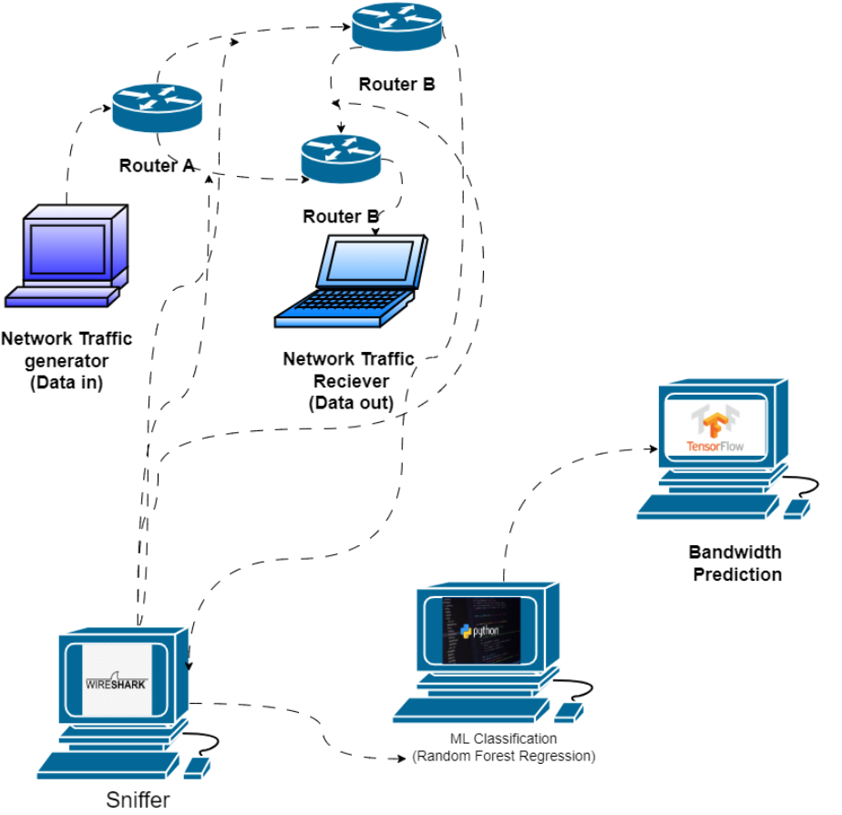
Figure 1: Flow Diagram of the virtual network
- GNS3 used to create a virtual network which we can see in Figure 1 network, VirtualBox which is used for the generator host and the receiver host. Wireshark, which is used as a sniffer to capture packets, Random Forest ML to classify packets which were labelled and it uses python to train the model. Scikit-learn to train the model and tensor Flow to predict bandwidth.

Methodology
Technical Problem Solution:
- Initiation:
Identified challenges in the current network resource allocation and propose ML-based classification and prediction solution. Defined project objectives, requirements and constraints related to data availability and computational resources. Assessed the technical ability of the ML models implemented within the existing network infrastructure works successfully.
- Planning:
Developed a plan on how the project will achieve its objectives by ensuring alignment to goals and resource capabilities. The alignment of goals and objectives was achieved with the help of using a gantt chart in Figure 2, 3, 4, 5 and 6. Broke down the project into manageable tasks which include data collection, preprocessing, model development, testing and deployment. Established timelines for each task using the Gantt chart on Figure 2, 3, 4, 5 and 6 to ensure realistic deadlines.
- Execution:
Implemented the project plan and integrated the ML models for network data classification and bandwidth prediction. Carried out the project activities as according to the Gantt chart even though it was not consistent. Monitored the ML model’s development process to ensure that the models meet the performance metrics and that they adhere to quality standards of a network.
- Monitoring and Controlling:
Tracked the project progress by ensuring to align with the plan in place and adjust if there were any deviations. Implemented a formal process to be able to handle changes in the project scope, schedule or resources to ensure that any modifications done are documented. Regular review and update of the risk management plan was in place to address evolving risks. Lastly was to verify that the project outputs meet the required standards and specifications.
- Closure:
Finalized all project activities to ensure that the solution is completed and approved. Confirmed that the project solution meets the criteria and withdraw temporary resources used during the project but unfortunately the project didn’t meet the requirements as I could not finish the project since I received a workstation 3 months before the completion date of the project. Recorded insights gained throughout the project which includes successes and areas for improvement.
Main steps in solving the project:
- Step 1: Download all the software I will need for the project, started by creating a network on GNS3 using VyOS routers which are imported from VirtualBox.
- Step 2: Configured 4 routers on VirtualBox before exporting them to gns3, on the configure I also configured OSPF protocol to all 4 routers and configured BGP to router 4. Configured the interfaces of the routers before connecting them together
- Step 3: Installed Ubuntu and Linux Mint on VirtualBox and duplicated the Linux Mint VM for host 2 which will be the receiver. Exported all the routers and VMs to GNS3 and connected them together and created a topology.
- Step 4: Configured the VM’s interfaces by assigning IP addresses and then tried to ping to the directly connected router. Installed ODL on Ubuntu as Ubuntu is the SDN controller and established BGP between router 4 and Ubuntu so that they can be able to communicate.
- Step 5: Configure OSPF on both hosts so that they can be able to communicate with every router on the network. Installed iperf3 on both hosts, python3, scikit-learn, pandas, Wireshark and TShark.
- Step 6: Coded Python scripts to label traffic on the receiver host and to train the model.
- Step 7: Trained the model using the data collected and labelled by the labelling script. Generated traffic using iperf3 from host 1 and using ping for ICMP traffic and then capture the traffic using Tshark on host 2, apply the labelling script and store the labelled data on a .csv file, train the model using the labelled data.
- Step 8: Ensured that the ML model achieves 100% and then save the classified traffic for prediction.

Project Deliverables
- The artefact is a Random Forest Classifier which collects packets from a network label the traffic and then classify it into three categories which are bulk, streaming and control. The model can be used in any network and when it is not familiar with the traffic it predicts the traffic and classify the traffic again and this is the flow that we can see on Figure 1.

Project Plan
The following Gantt chart on Figure 2, 3, 4, 5 and 6 presents a detailed project timeline for the traffic classification and resource-allocation system. It visualises each major phase of work from topology and data capture through to feature extraction, machine-learning training, real-time inference and SDN integration. The chart also highlights key milestones, durations and expected completion dates. By reviewing this timeline, it is easily understandable on what work has been being done, when, and how each activity supports the overall project objectives of automated traffic classification, bandwidth prediction and dynamic resource allocation.

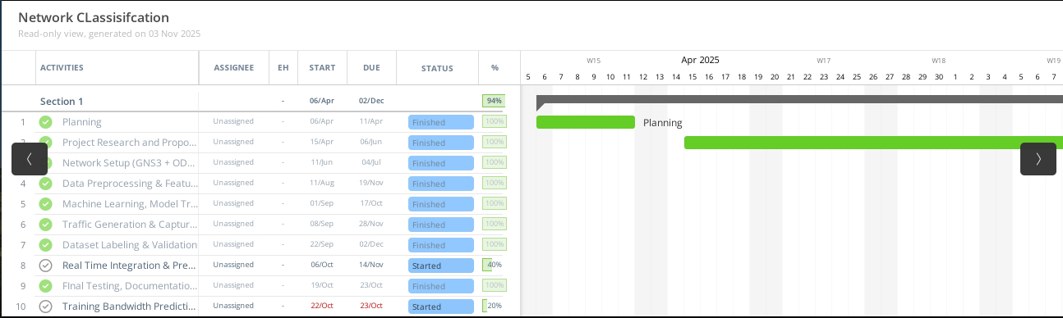
Figure 2: Gantt Chart with the complete project objectives
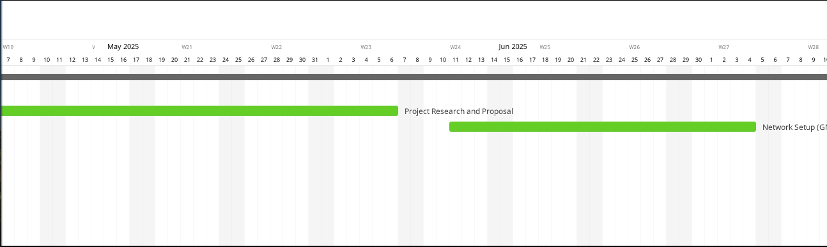
Figure 3: Gantt Chart showing the first two project objectives
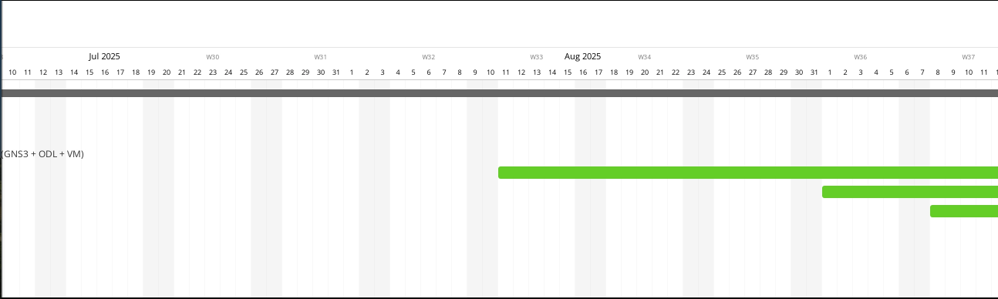
Figure 4: Gantt Chart showing the start of Machine Learning, Model Training and Evaluation
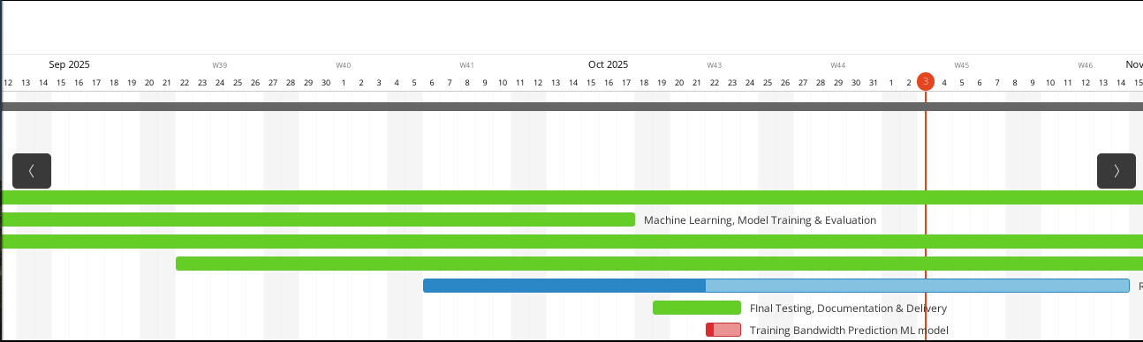
Figure 5: Gantt Chart showing Final Testing, Documentation, Delivery, Training Bandwidth prediction ML model
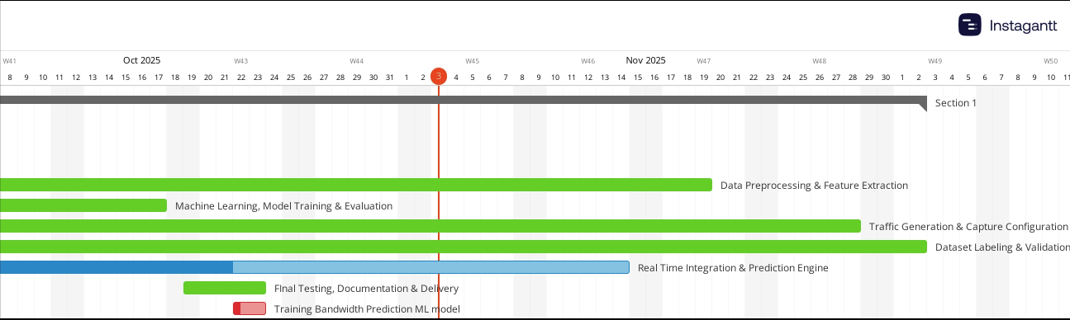
Figure 6: Shows the rest of the Gantt Chart objectives

Project Budget
To ensure the successful completion of the Network Data Classification and Bandwidth Prediction project, a detailed cost estimation was developed. The budget accounted for all essential resources that were required to do planning, designing, developing, testing, and deploying the system. The cost breakdown includes personnel, software and hardware resources, cloud computing, and contingency allowances as seen in Table 3. Personnel costs represent the largest portion of the budget, as skilled expertise in machine learning, network configuration, and data processing is crucial for achieving the project’s objectives.

Open-source tools such as Python, GNS3, and Wireshark were selected where possible to reduce expenses, while maintaining a small allocation for paid tools or licences to ensure flexibility and compliance. Table 3 summarizes the estimated costs, significance, and rationale behind each budgeted component:
Table 2: Project Budget Plan for Network Data Classification for automatic resource allocation
# | Item / Component | Estimated Cost (ZAR) | Importance & Significance
1 | Personnel – Project Manager (half-time, 6 months) | R 450,000 | Coordinates tasks, timelines and ensures delivery. Ensures that all objectives of the project are met. (Salary, 2025)
2 | Personnel – Data/ML Specialist (1 person, 6 months) | R 600,000 | Builds ETL pipeline, features and the ML models. (ERI, 2025)
3 | Personnel – Network/Testbed Engineer (1 person, 4 months) | R 300,000 | Sets up network topology, traffic generation and captures the traffic. (Payscale, 2025)
4 | Personnel – QA/Testing & Validation (1 person, 3 months) | R 180,000 | Ensures pipeline, model and system work reliably. (Payscale, 2025)
5 | Software Licences & Tools | R 60,000 | Although open source tools are used like Python, GNS3, Wireshark; budget allows for paid licences and specialised monitoring tools. Open source is more preferred to reduce cost, but budget reserves for any licence. (Pricecheck, 2025)
6 | Hardware/Infrastructure (VM hosting, network devices, captures) | R 100,000 | Required to run virtual machines, capture and storage, small network gear. Chose commodity hardware rather than enterprise switches to optimise cost. (Shop, 2025)
7 | Cloud Compute / Data Storage for ML Training & Prediction | R 80,000 | ML training and storage may require cloud instances or local GPUs and storage. Budgeted to ensure performance. (finout, 2025)

- The personnel costs dominates because skilled labour is the key driver when it comes to Machine Learning and in networking research projects more specifically in South Africa.
- The use of open-source tools like Python and Wireshark is done to keep costs manageable instead of very expensive software licenses. The use of virtualised infrastructure like using the VirtualBox and GNS3 is to also keep costs manageable instead of going for expensive hardware
- The software license cost is there for if a tool is not open-source and it can be paid using the license cost.

Engineering Professionalism
- Throughout the duration of working on the Network Data Classification for Automatic Resource Allocation project, I upheld high standards of professionalism and responsibility. I consistently demonstrated integrity by ensuring that all the work was accurate, transparent and aligned with the objectives of the project. I managed accountability by meeting deadlines and communicating challenges to my supervisor.
I continuously did my research on the SDN configurations, ML techniques, and data capture methods to find more ways to complete the project objectives. I ensured disciplined work ethic by maintaining proper documentation, attending meetings with my supervisor and following institutional guidelines throughout the project process.
- I conducted the project in accordance with the ECSA Code of Ethics, which emphasises responsibility, integrity and competence. I performed all analyses, implementation and testing while avoiding misrepresentation of results to achieve the project objectives. I undertook tasks that were under my technical capabilities and sought advice from my supervisor where needed. Even though the project was a digital system, I considered the potential effects of network misconfigurations and resource misallocation on users and systems to ensure public trust and safety.
I properly credited open-source software’s such as GNS3, Python, scikit-learn and Wireshark. I also properly credited the research material used throughout the project.
- The project was largely computer and network based, I did adhere to Occupational Health and Safety Act by maintaining a tidy and hazard-free workspace with proper cable management for the desktop and monitor I used for the project. I implement secure access to systems which reduced cyber risks. I followed the institutional safety protocols and immediately reported any malfunctioning equipment to my supervisor.
- The project relied on open-source tools, datasets, and reference material. All the tools and references were properly cited in the report and code comments. Open-source tools were used in compliance with their respective licences and terms of use. I developed a ETL script, flow aggregation logic, and model training with the help from an AI as guidance. External methods combined with methods from AI were tested, adapted and verified before inclusion to ensure originality and technical integrity of the final deliverable.

ECSA Graduate Attributes
- The graduate attribute 9 was a proposal which contained the research, planning and budget plans to go about the project. The graduate attribute 10 was ongoing the whole year whereby we give report on the progress of the project and then receive feedback from the supervisor and document via excel sheet. The graduate attribute 3 is whereby we were doing presentations on the progress of our projects and receive feedback on how best to do the presentations for GA 11. The graduate attribute 11 was the presentation and project presentation whereby we present the results of the final project and demonstrate the final projects.

Table 3: There are two ECSA graduate attributes to be assessed in the final project report
Column A | Column B
Graduate Attributes (GA’s) | - The student provides a detailed description of the approach taken to address each Graduate Attribute listed below.  - Each Graduate Attribute is clearly demonstrated, with evidence of the competence achieved.  - The summary provided in this column is thoroughly supported by the content of the final report, including references to specific sections (e.g., Section 1: Introduction, Section 4: Objectives of the Project).  - The assessment rubric for Graduate Attribute 3 is available at the end of this document.
Graduate Attribute 3: Engineering design  Perform procedural design and synthesis of components, systems, engineering works, products or processes. | - To identify and analyse the main objectives of the project, I reviewed the expanding demands of cloud services, the limitations of static resource allocations in a network, and the need for real-time bandwidth prediction in reducing congestion on the network (see Section1: Introduction; Motivation). To identify the projects main objectives, I also did some research on the causes for congestion on the network, the most demanding applications and the causes of misclassification on a network (See Section1: Introduction: Motivation). I then established a success criterion for the design solution which included the classification accuracy of at least 70%, prediction error within an acceptable threshold, real-time allocation responsiveness, scalable and a cost-effective virtual infrastructure. These criteria can be found in Section4: Objectives of the Project  - As the project is a broadly defined project of optimizing network resources, I explored several potential solution paths. I first considered the use of a small virtual network within Mininet on ubuntu Linux as it contains a built in SDN controller but then the use of ODL is sufficient in terms of features it contains. The next approach is that I evaluated a supervised machine-learning classifier which is Random Forest (see in Section 5: System Design) whereby the model categorizes traffic flow that is combined with a simple regression model to predict bandwidth. The final path I explored was a hybrid ML-SDN architecture which incorporated a real-time flow capture from a virtual network seating on GNS3 (see in Section 5: System Design) (see in Figure 7: Network Topology). I compared all the paths in terms of adaptability, data-labelling cost, encrypted traffic handling and infrastructure cost. I selected the hybrid approach because it is best balanced in adaptability, performance and practicality.  - How I implemented the design strategy is that I started with the strategy to construct a virtual network topology (four VyOS routers in GNS3, two hosts in VirtualBox, and an SDN controller running Open Daylight) as described in Figure 7: GNS3 Topology. I developed an extraction pipeline in Python (Section 5) that used packet capture which is Tshark. I then trained a Random Forest classifier and a bandwidth-prediction model (Section 5.5). In designing this solution, I encountered constraints and contextual elements such as cost-effectiveness and ethical considerations.  - To evaluate the design, I performed functional and performance testing under varying traffic conditions such as doing bulk transfers via iperf3, streaming flows which is UDP and control traffic which is ICMP. The results showed classification accuracy above 70% criterion and prediction error within the defined threshold (see Figure 9: Functional testing of Classification ML). The tests validate that the final design is functional and is viable in the virtual network environment.  - Throughout the project I integrated diverse research insights which involve multitask learning frameworks, SDN dynamic resource allocation, and technical knowledge which is ML classification and prediction. This was done to produce the final solution (see Section 3: Literature review). I connected the conceptual design of flow classification with the practical implementation of extraction pipeline, then linked that to the ML models and finally integrated those with the SDN controller (see Section 5: System Design). This synthesis of ideas, tools, and methods demonstrates the ability to unify theoretical research, technical implementation and system integration into a single working solution.

References
Bystrom, M. & Eisenstein, B., 2005. Practical Engineering Design. 1 ed. New York: CRC Press.
David Choffness, A. M. D. Z. &. K. S., 2016. Proceedings of the 15th ACM Workshop on Hot Topics in Networks. New York, Association for Computing Machinery.
Diego Kreutz, F. M. V. R. P. E. V. C. E. R. S. A. S. U., 2020. Software-Defined Networking: A Comprehensive Survey. IEEE Access, 103(1), pp. 155296-155235.
ERI, 2025. Salary Expert. [Online]
Available at: http://www.salaryexpert.com/salary/job/machine-learning-engineer/south-africa
[Accessed 20 October 2025].
finout, 2025. finout. [Online]
Available at: http://finout.io/blog/cloud-storage-pricing-comparison
[Accessed 20 October 2025].
Krishan Kumar, M. P. V., 2021. Network Traffic Classification Techniques: A Survey. IEEE Communications Survey & Tutorials, 23 January, pp. 451-482.
Payscale, 2025. Payscale. [Online]
Available at: http://www.payscale.com/research/ZA/Job=Network_Engineer/Salary
[Accessed 20 October 2025].
Pricecheck, 2025. Pricecheck. [Online]
Available at: http://www.pricecheck.co.za/categories/114/Software
[Accessed 20 October 2025].
Salary, I., 2025. Inquire Salary. [Online]
Available at: http://www.inquiresalary.co.za/project-manager-salary
[Accessed 22 October 2025].
Shop, F., 2025. FirstShop. [Online]
Available at: http://www.firstshop.co.za/products/pcbuilder-home-master-sektop-pc-intel-core-i5-12400-500gb-ssd-16gb-ram-win-11-home-309490
[Accessed 20 October 2025].
Zhiyong Liu, X. C. Y. C. Z. L., 2019. Networks, Deep Reinforcement Learning Based Dynamic Resource Allocation in 5G Ultra--Dense. China, IEEE Access.
Aqeel Luaibi Challoob, A. A. M. M. H. Y., 2024. Optimizing Network Performance through Advanced Machine Learning-Based Traffic Management. Central Asian Journal of Mathematical Theory and Computer Science, pp. 1 - 18.
Omeni, C., 2025. LinkedIn. [Online]
Available at: https://www.linkedin.com/pulse/managing-network-congestion-during-peak-usage-periods-christian-omeni-efhkf#:~:text=%F0%9F%9A%A6%20What%20Causes%20Network%20Congestion,implementing%20effective%20congestion%20management%20strategies.
Rehab H. Sarag, M. S. A. M. S. M. M. S., 2024. Machine-Learning-Based Traffic Classification in Software-Defined-Networks. pp. 1 -13.

Appendices
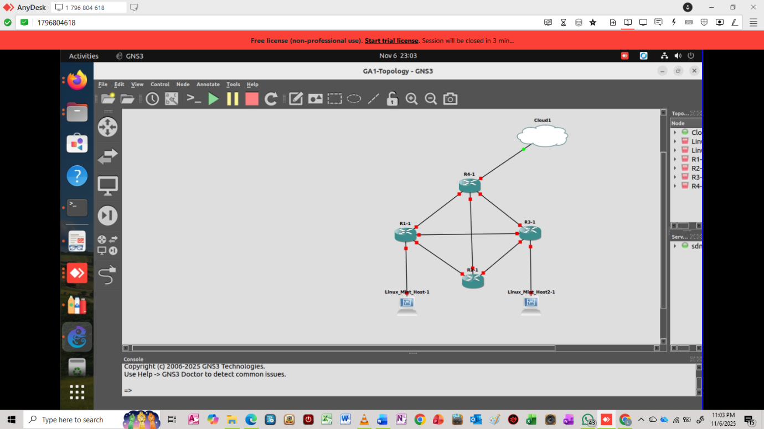
Figure 7: Virtual Network Topology
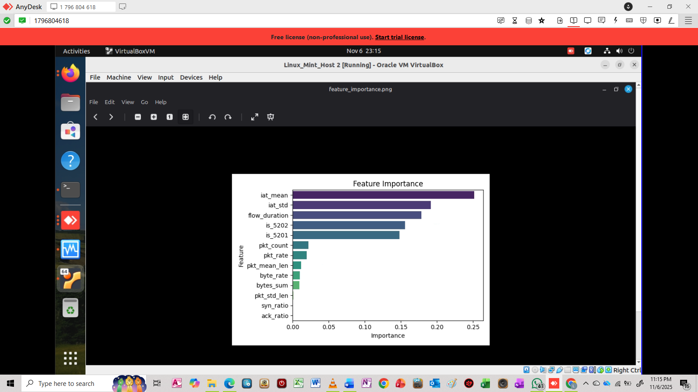
Figure 8: Priority Graph from Classification
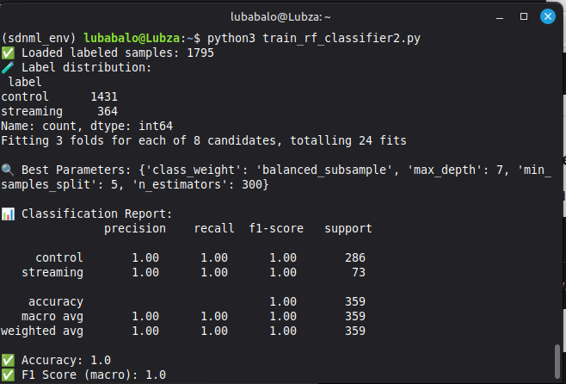
Figure 9: Functional testing of Classification ML
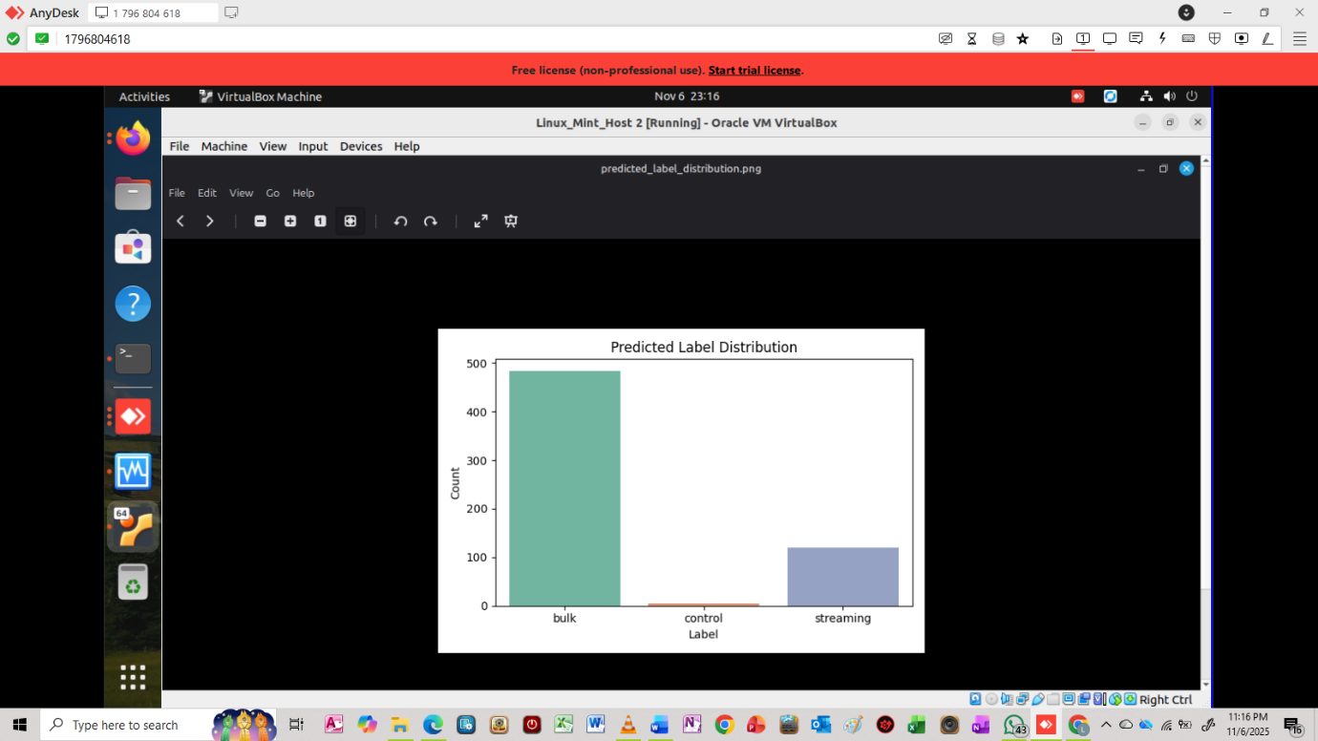

GA3: Engineering Design
Subject & code: Industrial Computing Design Project 3 (DES371S)
Examiner name: |  | Student name and number:
 | 1 (0-25%) | 2 (26-49%) | 3 (50-75%) | 4 (76-100%) | Assessor's Rating
INDICATORS & WEIGHTING | Needs work | Developing | Competent | Strong
1. Understanding the Design Scope:  Identify and analyze project objecteives, and plan and formulate crieria for an acceptable design solution. (20%) | Demonstrates minimal or no ability to understand and explain a design scope. | Demonstrates some ability to understand and explain a design scope. | Demonstrates an ability to understand and explain a design scope. | Demonstrates a comprehensive ability to understand and explain a design scope.
2. broadly-defined problem Solving: Considering Solutions:  Ability to develop an approach to solve a broadly-defined problem. (20%) | Considers a single approach to solving a broadly-defined problem. Does not consider consequences. | Considers a few approaches to solving a broadly-defined problem; doesn't always consider consequences. | Considers multiple approaches to solving a broadly-defined problem, which is justified and considers consequences. | Considers multiple approaches to solving a broadly-defined problem and develops a logical, consistent plan.
3. Implementing Design Strategy: Ability to execute a solution to an open-ended broadly-defined problem taking into consideration design requirements and pertinent contextual elements. (20%) | Demonstrates minimal or no ability to execute a solution. The solution does not directly attend to the broadly-defined problem. | Demonstrates some ability to execute a solution that attends to the broadly-defined problem but omits some design requirements and/or pertinent contextual elements. | Demonstrates an ability to execute a solution, taking into consideration design requirements and some contextual elements. | Recognise the consequences of the solution and articulate the reason for choosing a solution.
4. Evaluating Final Design: Ability to evaluate/confirm the functioning of the final design. (20%) | Demonstrates minimal or no ability to evaluate/confirm the functioning of the final design. | Demonstrates some ability to evaluate/confirm the functioning of the final design, but the evaluation lacks depth and/or is incomplete. | Demonstrates an ability to evaluate/confirm the functioning of the final design. The evaluation is complete and has sufficient depth. | Demonstrates a skillful (thorough/insightful/creative) ability to execute a solution taking into consideration all design requirements and pertinent contextual elements.
5. Connecting and Integrating: Ability to connect, integrate and transform ideas into solutions. (20%) | Demonstrates minimal or no ability to evaluate/confirm the functioning of the final design | Demonstrates some ability to evaluate/confirm the functioning of the final design, but the evaluation lacks depth and/or is incomplete. | Demonstrates an ability to evaluate/confirm the functioning of the final design. The evaluation is complete and has sufficient depth. | Insightful ability to evaluate/confirm the functioning of the final design, with deliberation for further improvement.
 |  |  |  | Final Mark (%)
Examiner:
Internal moderator:
External moderator:

